**Handons 8 – counterapp**

**App.js**

import React from 'react'

import CountPeople from './CountPeople'

export default function App() {

  return (

      <CountPeople/>

  )

}

**CountPeople.js**

    import './CountPeople.css';

    import { Component } from 'react';

    class CountPeople extends Component{

        constructor(){

        super()

        this.state={

            EntryCount:0,

            ExitCount:0,

            c:0

        };

  this.updateEntry = this.updateEntry.bind(this);

  this.updateExit =this.updateExit.bind(this);

        }

        updateEntry()

        {

            this.setState((prevState,props)=>{

            return{EntryCount: prevState.EntryCount + 1}

            });

        }

        updateExit()

        {

            this.setState((prevState, props)=>

            {

                 return{ExitCount:prevState.ExitCount+1}

            })

        }

        render()

        {

            return(

                <div>

                    <button onClick={this.updateEntry}>Login </button><span> {this.state.EntryCount} People Entered!!!</span>

                    <button onClick={this.updateExit}>Exit</button> <span> {this.state.ExitCount} People Left!!!</span>

                    </div>

            )

        }

    }

    export default CountPeople;

**CountPeople.css**

button{

    color:green;

    border-radius: 20%;

    margin-top: 23%;

    margin-left:23%;

    background-color: rgb(189, 255, 189);

}

**Handson 9 – circketapp**

**App.js**

import React from 'react'

import ListofPlayers, {IndianTeam, players, IndianPlayers} from './ListofPlayers';

import Scorebelow70 from './Scorebelow70';

import {OddPlayers, EvenPlayers, ListofIndianPlayers} from './IndianPlayers';

export default function App() {

  var flag = false;

  if(flag===true)

  {

  return (

<div>

    <ListofPlayers players={players}/>

    <Scorebelow70 players={players}/>

    </div>

  )

}

else{

  return(

    <div>

      <h2>Indian Team</h2>

      <h2>Odd Players</h2>

      {OddPlayers(IndianTeam)}

      <hr/>

      <h2>Even Players</h2>

      {EvenPlayers(IndianTeam)}

      <hr/>

      <ListofIndianPlayers IndianPlayers={IndianPlayers}/>

    </div>

  );

}}

**IndianPlayers.js**

export const OddPlayers =([first,,third,,fifth])=>

{

    return(

        <div>

            <li>First: {first}</li>

            <li>Third: {third}</li>

            <li>Fifth: {fifth}</li>

        </div>

    )

};

export const EvenPlayers =([,second,,fourth,,sixth])=>

{

    return(

        <div>

          <li>Second: {second}</li>

            <li>Fourth: {fourth}</li>

            <li>sixth: {sixth}</li>

        </div>

    )

}

export const ListofIndianPlayers =({IndianPlayers})=>

{

    return(

        <div>

            <h2>List of Indian Players Merged: </h2>

           {IndianPlayers.map((item)=>

           {return(

            <li>Mr. {item}</li>)}

        )}

        </div>

    )

}

**ListofPlayers.js**

export const players = [

    { name: 'Jack', score: 50 },

    { name: 'Michael', score: 70 },

    { name: 'John', score: 40 },

    { name: 'Ann', score: 61 },

    { name: 'Elisabeth', score: 61 },

    { name: 'Sachin', score: 95 },

    { name: 'Dhoni', score: 100 },

    { name: 'Virat', score: 84 },

    { name: 'Jadeja', score: 64 },

    { name: 'Raina', score: 75 },

    { name: 'Rohit', score: 80 }

  ];

 export const IndianTeam=["Sachin1", "Dhoni2","Virat3", "Jadeja4", "Raina5","Rohit6"];

 const T20Players = ['First Player', ' Second Player', 'Third Player'];

 const RanjiTrophyPlayers=['Fourth Player', 'Fifth Player', 'Sixth Player'];

 export const IndianPlayers = [...T20Players,...RanjiTrophyPlayers];

const ListofPlayers = ({players}) => {

  return (

    <div>

      <h2> Cricket Players List</h2>

      <ul>

        {players.map(item => (

          <li key={item.name}>

            Mr. {item.name}: {item.score}

          </li>

        ))}

      </ul>

      <hr />

    </div>

  );

};

export default ListofPlayers;

**Handson 10 – officespacerentalapp**

App.js

import React from 'react';

import './App.css';

import office1 from './content/Office1.jpeg';

import office2 from './content/Office2.jpeg';

import office3 from './content/Office3.jpeg';

const officeList = [

  {

    Name: "DBS",

    Rent: 50000,

    Address: "Chennai",

    imgSrc: office1

  },

  {

    Name: "WeWork",

    Rent: 70000,

    Address: "Bangalore",

    imgSrc: office2

  },

  {

    Name: "Regus",

    Rent: 60000,

    Address: "Mumbai",

    imgSrc: office3

  }

];

const App = () => {

  return (

    <div>

      <h1> Office Space Listings</h1>

      {officeList.map((item, index) => {

        const rentColorClass = item.Rent <= 60000 ? 'textRed' : 'textGreen';

        return (

          <div key={index} style={{ border: "1px solid #ccc", margin: "10px", padding: "10px" }}>

            <img src={item.imgSrc} alt="Office Space" width="25%" height="25%" />

            <h2>{item.Name}, at Affordable Range</h2>

            <h3>Name: {item.Name}</h3>

            <h3 className={rentColorClass}>Rent: Rs. {item.Rent}</h3>

            <h3>Address: {item.Address}</h3>

          </div>

        );

      })}

    </div>

  );

};

export default App;

**App.css**

.textRed {

  color: red;

  font-weight: bold;

}

.textGreen {

  color: green;

  font-weight: bold;

}

Handson 11 – eventexamplesapp

EventExamples.js

import React, { Component } from 'react';

class EventExamples extends Component {

  constructor(props) {

    super(props);

    this.state = {

      counter: 0

    };

  }

  // Increment counter and say hello

  incrementCounter = (e) => {

    this.setState(prevState => ({

      counter: prevState.counter + 1

    }));

    this.sayHello();

  }

  sayHello = () => {

    console.log("Hello! This is a static message.");

  }

  // Decrement counter

  decrementCounter = () => {

    this.setState(prevState => ({

      counter: prevState.counter > 0 ? prevState.counter - 1 : 0

    }));

  }

  // Say welcome with argument

  sayWelcome = (message) => {

    alert(`${message} to our app!`);

  }

  // Synthetic event handler

  handleClick = (e) => {

    alert("I was clicked");

    console.log(e); // SyntheticEvent object

  }

  render() {

    return (

      <div>

        <div>

          <p> {this.state.counter}</p>

          <div>

          <button onClick={this.incrementCounter}>Increment</button>

          </div>

          <button onClick={this.decrementCounter}>Decrement</button>

        </div>

        <div>

          <button onClick={() => this.sayWelcome("Welcome")}>Say Welcome</button>

        </div>

        <div>

          <button onClick={this.handleClick}>Click on me</button>

        </div>

      </div>

    );

  }

}

export default EventExamples;

**CurrencyConverter.js**

import React, { Component } from 'react';

class CurrencyConvertor extends Component {

  constructor(props) {

    super(props);

    this.state = {

      amount: '',

      currency: '',

      convertedAmount: null

    };

  }

  handleInputChange = (e) => {

    this.setState({

      [e.target.name]: e.target.value

    });

  }

  handleSubmit = (e) => {

    e.preventDefault();

    const { amount, currency } = this.state;

    if (currency === 'Euro') {

      // Convert INR to Euro (approximate rate: 1 Euro = 80 INR)

      const converted = parseFloat(amount) / 80;

      this.setState({ convertedAmount: converted });

      alert(`Converting to Euro. Amount is ${converted}`);

    }

  }

  render() {

    return (

      <div className='form-container'>

        <h1 >Currency Convertor!!!</h1>

        <form onSubmit={this.handleSubmit}>

          <div>

            <label>

              Amount:

              <input

                type="number"

                name="amount"

                value={this.state.amount}

                onChange={this.handleInputChange}

              />

            </label>

          </div>

          <div>

            <label>

              Currency:

              <textarea

                name="currency"

                value={this.state.currency}

                onChange={this.handleInputChange}

              >

              </textarea>

            </label>

          </div>

          <button className="submit-button" type="submit">Submit</button>

        </form>

        {this.state.convertedAmount && (

          <p>

            Converted Amount: {this.state.convertedAmount.toFixed(2)} {this.state.currency}

          </p>

        )}

      </div>

    );

  }

}

export default CurrencyConvertor;

App.js

import React from 'react';

import EventExamples from './components/EventExamples';

import CurrencyConvertor from './components/CurrencyConvertor';

import './App.css';

function App() {

  return (

    <div className="App">

      <EventExamples />

      <hr />

      <CurrencyConvertor />

    </div>

  );

}

export default App;

App.css

h1{

  color:green;

}

p{

  padding-left:10px;

}

input{

  width:150px;

  margin-left:30px;

  margin-bottom: 10px;

}

textarea{

  width:152px;

  margin-left:25px;

  margin-top:10px;

}

.form-container{

width:350px;

}

.submit-button{

  margin-left:130px;

}

.App-logo {

  height: 40vmin;

  pointer-events: none;

}

@media (prefers-reduced-motion: no-preference) {

  .App-logo {

    animation: App-logo-spin infinite 20s linear;

  }

}

.App-header {

  background-color: #282c34;

  min-height: 100vh;

  display: flex;

  flex-direction: column;

  align-items: center;

  justify-content: center;

  font-size: calc(10px + 2vmin);

  color: white;

}

.App-link {

  color: #61dafb;

}

@keyframes App-logo-spin {

  from {

    transform: rotate(0deg);

  }

  to {

    transform: rotate(360deg);

  }

}

Handson 12 – ticketbookingapp

**Greeting.js**

import React from 'react';

function UserGreeting() {

    return <h1>Welcome back</h1>;

}

function GuestGreeting() {

    return <h1>Please sign up.</h1>;

}

function Greeting({ isLoggedIn }) {

    if(isLoggedIn)

        { return(<UserGreeting />)

        }

        else{

            return(<GuestGreeting />)

        }

}

export default Greeting;

**LoginButton.js**

import React from 'react';

function LoginButton({ onClick }) {

    return (

        <div>

            <button onClick={onClick}>Login</button>

        </div>

    );

}

export default LoginButton;

**LogoutButton.js**

import React from 'react';

function LogoutButton({ onClick }) {

    return (

        <div>

            <button onClick={onClick} >Logout</button>

        </div>

    );

}

export default LogoutButton;

**App.js**

import React, { useState } from 'react';

import Greeting from './components/Greeting';

import LoginButton from './components/LoginButton';

import LogoutButton from './components/LogoutButton';

import './App.css';

function App() {

    const [isLoggedIn, setIsLoggedIn] = useState(false);

    const handleLoginClick = () => {

        setIsLoggedIn(true);

    };

    const handleLogoutClick = () => {

        setIsLoggedIn(false);

    };

    return (

        <div className="App" >

            <Greeting isLoggedIn={isLoggedIn} />

            {isLoggedIn ? (

                <LogoutButton onClick={handleLogoutClick} />

            ) : (

                <LoginButton onClick={handleLoginClick} />

            )}

        </div>

    );

}

export default App;

**Handson 13 – bloggerapp**

**App.js**

import React from 'react';

import BookDetails from './Components/BookDetails';

import BlogDetails from './Components/BlogDetails';

import CourseDetails from './Components/CourseDetails';

import { books } from './data/books';

import './App.css';

function App() {

  return (

    <div className="App">

      <div className="container">

        <div className="box mystyle1">

          <h1>Course Details</h1>

          <CourseDetails />

        </div>

        <div className="box st2">

          <h1>Book Details</h1>

          <BookDetails books={books} />

        </div>

        <div className="box v1">

          <h1>Blog Details</h1>

          <BlogDetails />

        </div>

      </div>

    </div>

  );

}

export default App;

**App.css**

.container {

  display: flex;

  justify-content: space-around;

  margin-top: 50px;

}

.box {

  padding: 20px;

  width: 25%;

}

.mystyle1 {

  border-right: 5px solid green;

}

.st2 {

  border-right: 5px solid green;

}

.v1 {

  border-right: none;

}

**BlogDetails.js**

import React from 'react';

const BlogDetails = () => {

  const showInstall = true;

  return (

    <div>

      <h2>React Learning</h2>

      <h4><i>Stephen Biz</i></h4>

      <p>Welcome to learning React!</p>

      {showInstall && (

        <>

          <h2>Installation</h2>

          <h4><i>Schwezdenier</i></h4>

          <p>You can install React from npm.</p>

        </>

      )}

    </div>

  );

};

export default BlogDetails;

**BookDetails.js**

import React from 'react';

const BookDetails = (props) => {

  return (

    <ul>

      {props.books.map((book) => (

        <div key={book.id}>

          <h3>{book.bname}</h3>

          <h4>{book.price}</h4>

        </div>

      ))}

    </ul>

  );

};

export default BookDetails;

**CourseDetails.js**

import React from 'react';

const CourseDetails = () => {

  const courses = [

    { name: 'Angular', date: '4/5/2021' },

    { name: 'React', date: '6/3/20201' }, // Typo intentional to match your image

  ];

  return (

    <div>

      {courses.length > 0 ? (

        courses.map((course, index) => (

          <div key={index}>

            <h2>{course.name}</h2>

            <h4>{course.date}</h4>

          </div>

        ))

      ) : (

        <p>No courses available</p>

      )}

    </div>

  );

};

export default CourseDetails;

**Books.js**

export const books = [

  { id: 101, bname: 'Master React', price: 670 },

  { id: 102, bname: 'Deep Dive into Angular 11', price: 800 },

  { id: 103, bname: 'Mongo Essentials', price: 450 },

];

**Handson 14 – employeesapp**

**Employee.js**

class Employee {

    constructor(id, name, email, phone){

        this.id=id;

        this.name=name;

        this.email=email;

        this.phone=phone;

    }

}

const EmployeesData=[

    new Employee(101,'Jojo','jojo@congizant.com','98238971234'),

    new Employee(102,'Sam','sam@congizant.com', '9981184126'),

    new Employee(103,'Elisa','elisa@cognizant.com','9989389735')

];

export default Employee;

export {EmployeesData};

EmployeeCard.js

import Styles from './EmployeeCard.module.css';

function EmployeeCard(props) {

    return (

        <div className={Styles.Card}>

            <h3>{props.employee.name}</h3>

            <p>{props.employee.email}</p>

            <p>{props.employee.phone}</p>

            <p>

                <a href="#" className={props.theme}>Edit</a>

                <a href="#" className={props.theme}>Delete</a>

            </p>

        </div>

    );

}

export default EmployeeCard;

**EmployeeCard.css**

.Card{

    display: inline-block;

    width: 25%;

    border:1px solid #999;

    border-radius: 5px;

    margin:10px;

    padding:10px;

}

EmployeeList.js

import EmployeeCard from './EmployeeCard';

function EmployeesList(props) {

    return (

        <div>

            <h1>Employees List</h1>

            {

                props.employees.map(employee =>

                    <EmployeeCard theme={props.theme} employee={employee} key={employee.id} />

                    )}

        </div>

    );

}

export default EmployeesList;

Themecontext.js

// ThemeContext.js

import { createContext } from 'react';

const ThemeContext = createContext('light');

export default ThemeContext;

App.js

import './App.css';

import { EmployeesData } from './Employee';

import EmployeesList from './EmployeesList';

import { useState } from 'react';

import ThemeContext from './ThemeContext'

function App() {

  const Employees = EmployeesData;

  const [theme, setTheme] = useState('light');

  return (

    <ThemeContext.Provider value={theme}>

      <div className={`app-container ${theme}`}>

        <label>SELECT A THEME </label>

        <select onChange={(e) => setTheme(e.target.value)}>

          <option value='light'>Light</option>

          <option value='dark'>Dark</option>

        </select>

        <EmployeesList employees={Employees} />

      </div>

    </ThemeContext.Provider>

  );

}

export default App;

**App.css**

.app-container.light {

  background-color: white;

  color: black;

}

.app-container.dark {

  background-color: #121212;

  color: white;

}

.employees-list.light {

  background-color: #f5f5f5;

  padding: 10px;

}

.employees-list.dark {

  background-color: #333;

  padding: 10px;

}

Handson 15 – ticketraisingapp

**ComplaintRegister.js**

import React, { Component } from 'react';

class ComplaintRegister extends Component {

  constructor(props) {

    super(props);

    this.state = {

      ename: '',

      complaint: '',

      NumberHolder: Math.floor(1 + Math.random() * 100) // Generate ID between 1–100

    };

  }

  handleChange = (event) => {

    this.setState({

      [event.target.name]: event.target.value

    });

  }

  handleSubmit = (event) => {

    const msg = `Thanks ${this.state.ename}\nYour Complaint was Submitted.\nTransaction ID is: ${this.state.NumberHolder}`;

    alert(msg);

    event.preventDefault();

  }

  render() {

    const inputStyle = { width: '300px', padding: '8px' };

    return (

      <div style={{ textAlign: 'center', padding: '30px' }}>

        <h2 style={{ color: 'red' }}>Register your complaints here!!!</h2>

        <form onSubmit={this.handleSubmit}>

          <div>

            <label style={{ marginRight: '10px' }}>Name:</label>

            <input

              type="text"

              name="ename"

              value={this.state.ename}

              onChange={this.handleChange}

              style={inputStyle}

            />

          </div>

          <br />

          <div>

            <label style={{ marginRight: '10px' }}>Complaint:</label>

            <textarea

              name="complaint"

              value={this.state.complaint}

              onChange={this.handleChange}

              rows="4"

              style={inputStyle}

            />

          </div>

          <br />

          <button type="submit">Submit</button>

        </form>

      </div>

    );

  }

}

export default ComplaintRegister;

**App.js**

import React from 'react';

import ComplaintRegister from './ComplaintRegister';

function App() {

  return (

    <div>

      <ComplaintRegister />

    </div>

  );

}

export default App;

**Handson 16 – mailregisterapp**

**RegisterForm.js**

import React, { Component } from 'react';

import './RegisterForm.css';

class RegisterForm extends Component {

  constructor(props) {

    super(props);

    this.state = {

      name: '',

      email: '',

      password: ''

    };

  }

  handleChange = (e) => {

    this.setState({ [e.target.name]: e.target.value });

  };

  handleSubmit = (e) => {

    e.preventDefault();

    const { name, email, password } = this.state;

    // Validate name

    if (name.length < 5) {

      alert("Name must be at least 5 characters long.");

      return;

    }

    // Validate email format

    const emailRegex = /^[^\s@]+@[^\s@]+\.[^\s@]+$/;

    if (!emailRegex.test(email)) {

      alert("Please enter a valid email address.");

      return;

    }

    // Validate password

    if (password.length < 8) {

      alert("Password must be at least 8 characters long.");

      return;

    }

    alert(`Name: ${name}`);

    alert(`Email: ${email}`);

    alert(`Password: ${password}`);

    alert("Form submitted!");

  };

  render() {

    return (

      <div>

        <h2>Register Here!!!</h2>

        <div className="form-container">

          <form onSubmit={this.handleSubmit}>

            <div className="form-row">

              <label>Name:</label>

              <input

                type="text"

                name="name"

                value={this.state.name}

                onChange={this.handleChange}

                required

              />

            </div>

            <div className="form-row">

              <label>Email:</label>

              <input

                type="email"

                name="email"

                value={this.state.email}

                onChange={this.handleChange}

                required

              />

            </div>

            <div className="form-row">

              <label>Password:</label>

              <input

                type="password"

                name="password"

                value={this.state.password}

                onChange={this.handleChange}

                required

              />

            </div>

            <button type="submit">Submit</button>

          </form>

        </div>

      </div>

    );

  }

}

export default RegisterForm;

**RegisterForm.css**

.form-container {

  width: 280px;

  margin: 40px auto;

  padding: 20px;

  padding-top:0;

}

h2{

  color:red;

  font-size:xx-large;

display: flex;

padding-left: 550px;

padding-bottom: 0;

}

button{

  margin-left:150px;

}

.form-row {

   display: flex;

  justify-content: space-between;

  margin-bottom: 15px;

}

.form-row label {

  flex: 1;

}

.form-row input {

  flex: 2;

  padding: 0px;

}

**App.js**

import React from 'react'

import RegisterForm from './RegisterForm'

export default function App() {

  return (

    <div>

      <RegisterForm/>

    </div>

  )

}

**Output:**

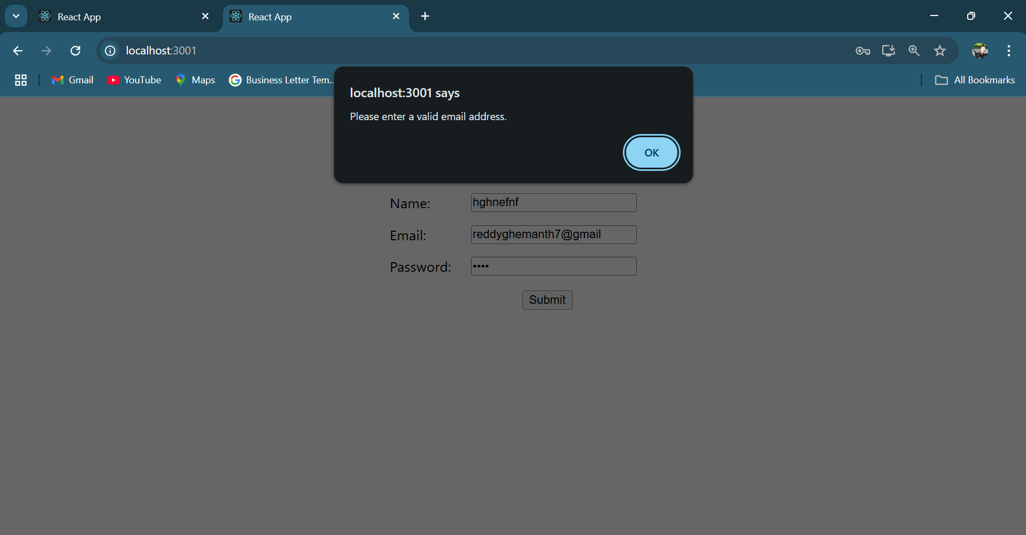

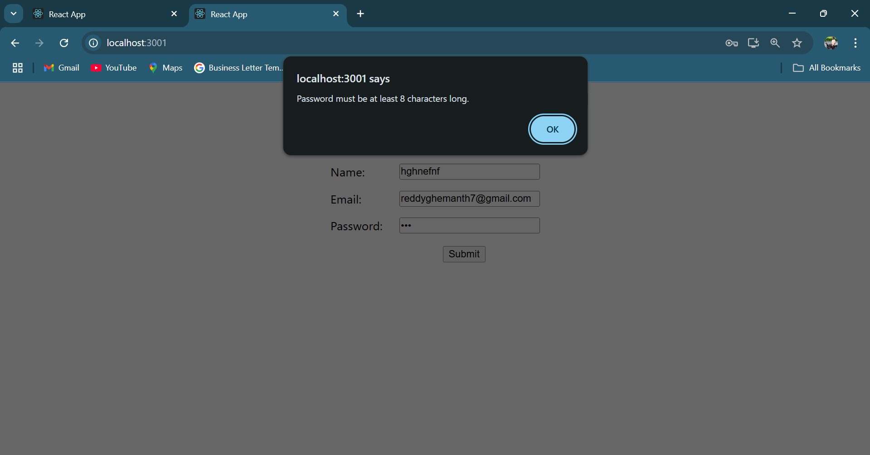

**Handons -17 fecthuserapp**

**GetUser.js**

import React, { Component } from 'react';

class GetUser extends Component {

  constructor(props) {

    super(props);

    this.state = {

      person: null,

      loading: true

    };

  }

  async componentDidMount() {

    const url = "https://api.randomuser.me/";

    const response = await fetch(url);

    const data = await response.json();

    this.setState({ person: data.results[0], loading: false });

    console.log(data.results[0]);

  }

  render() {

    const { loading, person } = this.state;

    if (loading) {

      return <div>Loading...</div>;

    }

    return (

      <div>

        <h2>{person.name.first} {person.name.last}</h2>

        <img src={person.picture.large} alt="User" />

      </div>

    );

  }

}

export default GetUser;

**App.js**

import React from 'react'

import GetUser from './GetUser'

import './App.css';

export default function App() {

  return (

    <div className='App'>

    <GetUser/>

    </div>

  )

}

Handson 18 –

Handson 19